YouTube Videos

Files as large as our speeches are unable to be uploaded to Blackboard. So we will be uploading our speeches on YouTube. Don't fret though, you will mark them as "unlisted" so only your classmates and I can view them. You will then post a link to your speeches in "Student Share" folder so everyone in the class, including myself can view it. Also please remember to also post your link under the assignment submissions box so I can grade them! I understand it's a little nerve wracking initially, but once you complete your introduction speech you'll see just how easy it is! Below there is a step by step directions, video to watch how to upload, or photos to help walk you through this process. Let me know if you have any questions!

How to upload videos
To get started uploading videos on YouTube, follow the steps below:
- Sign into YouTube.
- Click the Upload link at the top of the page.
- Select the video you'd like to upload from your computer. You can also record a video from your webcam, or create a video slideshow.

Once the upload is completed YouTube will send you an email to notify you that your video is done uploading and processing. IMPORTANT: Remember to mark your speech as “unlisted”. If you mark it as “private” I cannot view it.

For you Visual Learners!
Here is a link to a YouTube video that can also show you how to do everything listed:
http://www.youtube.com/watch?v=TrpyRFLYhD4
Just highlight and copy and paste this link into your browser to view.

Uploading to YouTube Photo Examples!

Before you begin make sure you have an account with YouTube. If you do not don’t worry it’s very simple to sign up. Simply go to YouTube.com and to the top right-hand corner there should be a box titled “Sign In”. Click this and you should be able to sign up for an account.
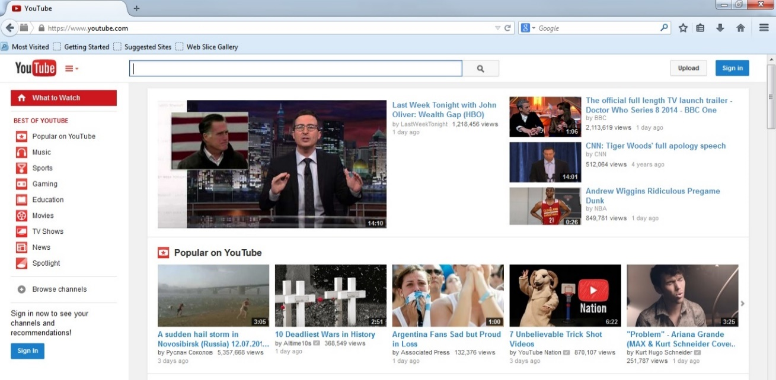

Now that you have an account and have signed in AND already recorded your speech (with knowledge of where you saved it) you click the “upload” button at the top right-hand corner of the page.

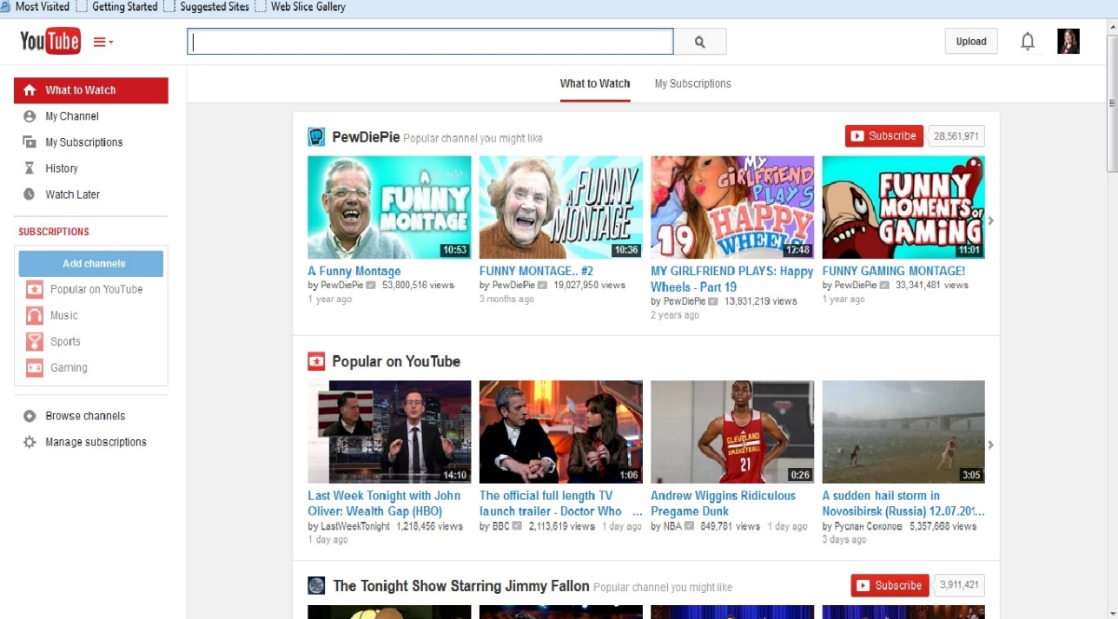

After you click the “upload” button it takes you to a new screen. BEFORE you select your video you want to upload select the drop down arrow where it says “public” and change it to “unlisted”.
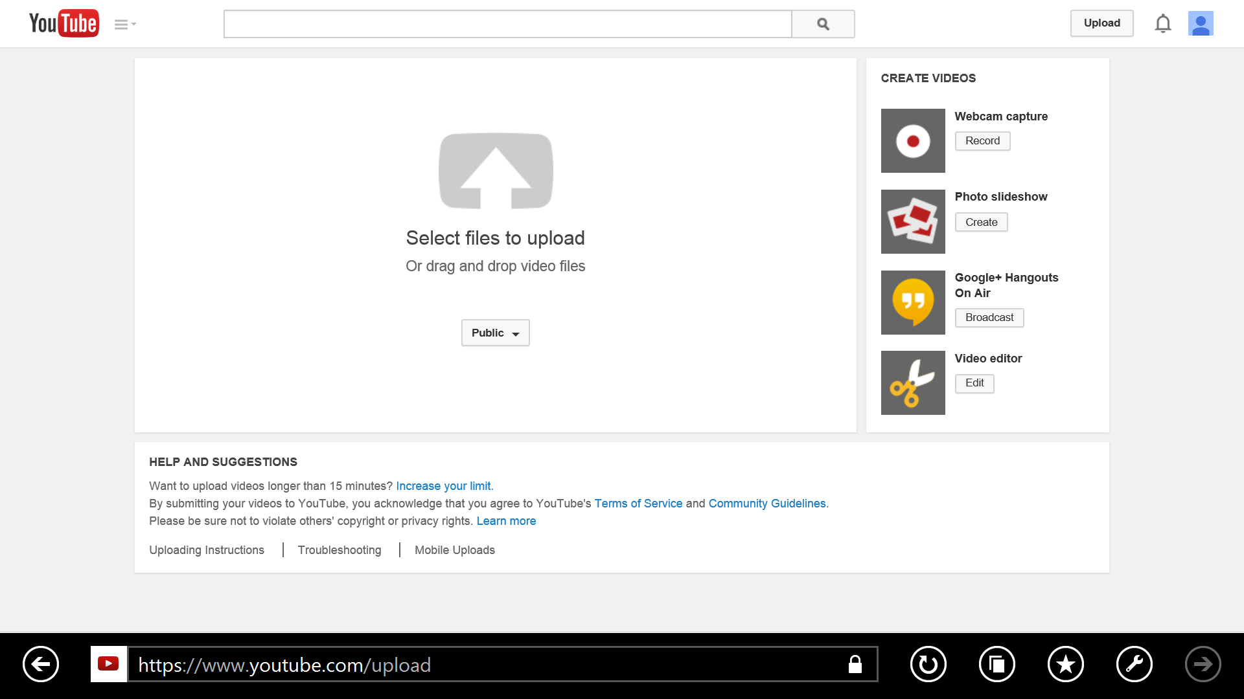

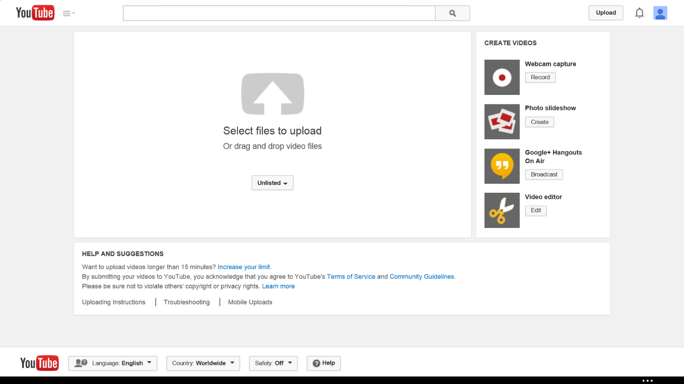

Now you simply select the video you want to upload and patiently wait for it to upload. At this screen you are able to title your video and give a short description. If you have slow internet or poor connection this part may take a LONG time. Don’t close out of the screen but you are able to leave this unattended and do something else if necessary. After it is uploaded you will see a web-link to the upper left-hand corner of your screen. Copy this and paste it in Ask the Professor under the Communicate tab AND also paste this web-link under the designated assignment folder submissions message box. This way your classmates can view it and I can grade it.
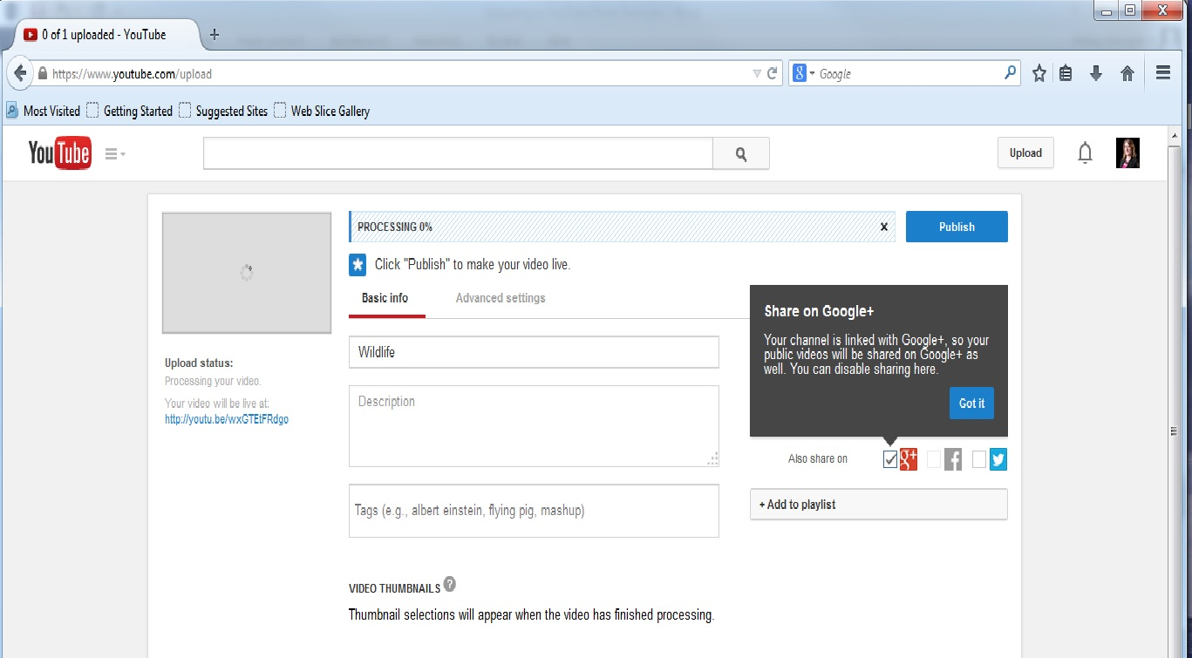

If you have any questions feel free to contact me or your student advisor and we will help you every step of the way!

