CS 265 Programming in C++
<Class Term Date/Section – e.g. 08-JAN-20 - 03-MAR-20 [1173]>
<Instructor>
Assignment Template
<INSERT YOUR NAME>
<Insert Date>
< Submission Number>

Week # Assignment

Program Description
<Insert the program Description>

Program Code
<Copy the code from C++ compiler and paste it here>
Program Execution
< A screenshot of a successful run displaying all requested outputs and date and time of code execution>
Reflection
<In one to two well-developed paragraphs, reflect on your experience developing the program. What steps did you follow? What methodology did you implement? Were you surprised or challenged at any point? What obstacles did you resolve? Any tips you would share with the other students?>

Code and Screen Shot Submission Example

Week # Assignment

Sample Program Description

This program displays the prompt “Hello World”. It demonstrates the use of the printf function in C++.

Sample Program Code
#include <stdio.h>

int main()
{
//display Hello World
printf("Hello World");

return 0;
}

Sample Program Execution
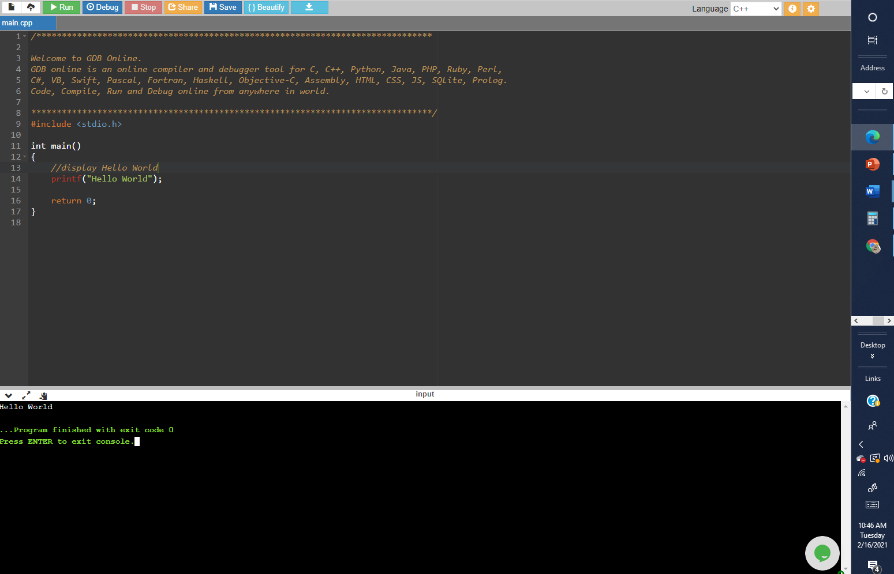
Date/Time Stamp
Successful execution run and output

Reflection
- What steps did you follow?
- What methodology did you implement?
- Were you surprised or challenged at any point?
- What obstacles did you resolve?
- Any tips you would share with the other students?

