Macroeconomics – Week #2 Assignment

Demand and Supply Exercises
Directions: Fill in the boxes (QD, QS, D, S, P, Q) in the next three demand and supply exercises. Based upon the event, what can we expect to occur for the market? Use a “0” (zero) if nothing will occur for that particular variable, a “+” (plus) if an increase, or a “-“ (negative) if a reduction. QD stands for Quantity Demanded, QS for Quantity Supplied, D for Demand, S for Supply, P for Price, and Q for Quantity.

Problem 1
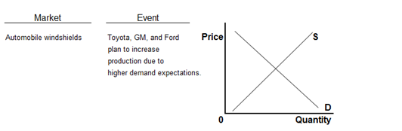
QD | QS | D | S | P | Q

Problem 2
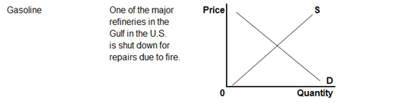
QD | QS | D | S | P | Q

Problem 3
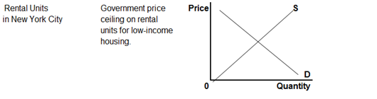
QD | QS | D | S | P | Q

