This practice exercise will show you how to begin a search, how to qualify the authors of sources, and how to narrow your search from thousands of sources to a more manageable number of sources.

- In G-Life, click on the “Resources” tab.
- Click on “Online Library Resources”
- Click on the EBSCOhost icon
- Click on “EBSCOhost Research Databases”
For this exercise, select only the “Academic Search Complete” database, and click on the “Continue” button.

Type Population Health in the box and click the “Search” button.
How many sources are listed in Search Results? ______
Look at the left hand side of the screen. Review the “Limit To” information.
What is the range of years covered in the search? ______
Keep scrolling down on the left hand side, and review the “Source Types”
How many magazine articles? ______
How many scholarly sources (academic journals)? ______
Click on “Academic Journals”
What is the title of the first scholarly article that appears? ______
Click on the title of that first article to go to the detailed record view.
On the right hand side of the screen under “Tools”, click on “Cite” and copy the APA citation in the space below:
_____________________________________________________________________________

How do you qualify the authors?
Click the back arrow (left top screen, above the blue ribbon)
Now let’s work with the second entry in your search results. Click on the title of that entry to go to the detailed record.
List the author(s) for the second source displayed in your search results.
___________________________________________________________________________
What are qualifications? In scholarly journals, authors must list their titles, positions, and affiliation with a University or organization. These are the qualifications that point to the authors’ credibility or expertise. You will see the list of authors at the top of the detailed record. Are there superscripted numbers next to the authors’ names? This is a hint to scroll down the page to the “Author Affiliations.”
Write the authors’ affiliations in the space below:
__________________________________________________________________________________
Hint #2: Look on the left hand side of the screen. Under “Detailed Record” you will see links to either a PDF version of the article, or an HTML link. Open the article and look for the “About the Authors” or some similar feature usually found on the first page of the scholarly article. Sometimes, author information may appear at the end of the article, before the References.
Write the authors’ qualifications (i.e. affiliation with a University or organization, or other information that points to the author as a qualified expert) in the space below:
__________________________________________________________________________________
To whom should you write if you have questions about the article?

__________________________________________________________________________________

How do you narrow your search further?

Return to the “Search Results” page.
On the left-hand side of the page – under the “Limit To” section, change the publication date from 1951 to 2010.
Note: You can change the date by typing directly in the date boxes, or by sliding the arrows below the date boxes.

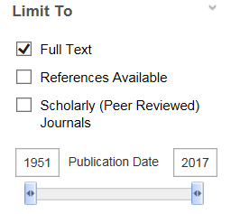
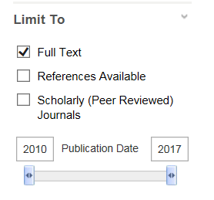

How many sources are now displayed in the “Search Results”? ________
Add the word ethics to the search (your search is now Population Health Ethics)
How many sources does EBSCO have in the Academic Search Complete? _________
How many scholarly articles on Population Health Ethics? __________
What is the first article that appears?
_______________________________________________________________________

