Trading Cards: Use the US Fish and Wildlife Service, your local conservation agency or the UN’s Red List to
Sabertooth Cat
Machairdous horribilis
Status: Extinct
Distribution: once throughout China
Description: Large cat similar to a modern day lion or leopard with large curved canines. The jaw structure limited how wide it could stretch its jaw. Also thought to be slow runner.
Cause of decline: hunting and climate change
Recovery Plan:
None:

Reference
https://www.livescience.com/56775-sabertooth-cat-bite-diversity.html
https://www.livescience.com/25848-starvation-extinction-sabertooth-cats.html
Created by: Sarah Powell

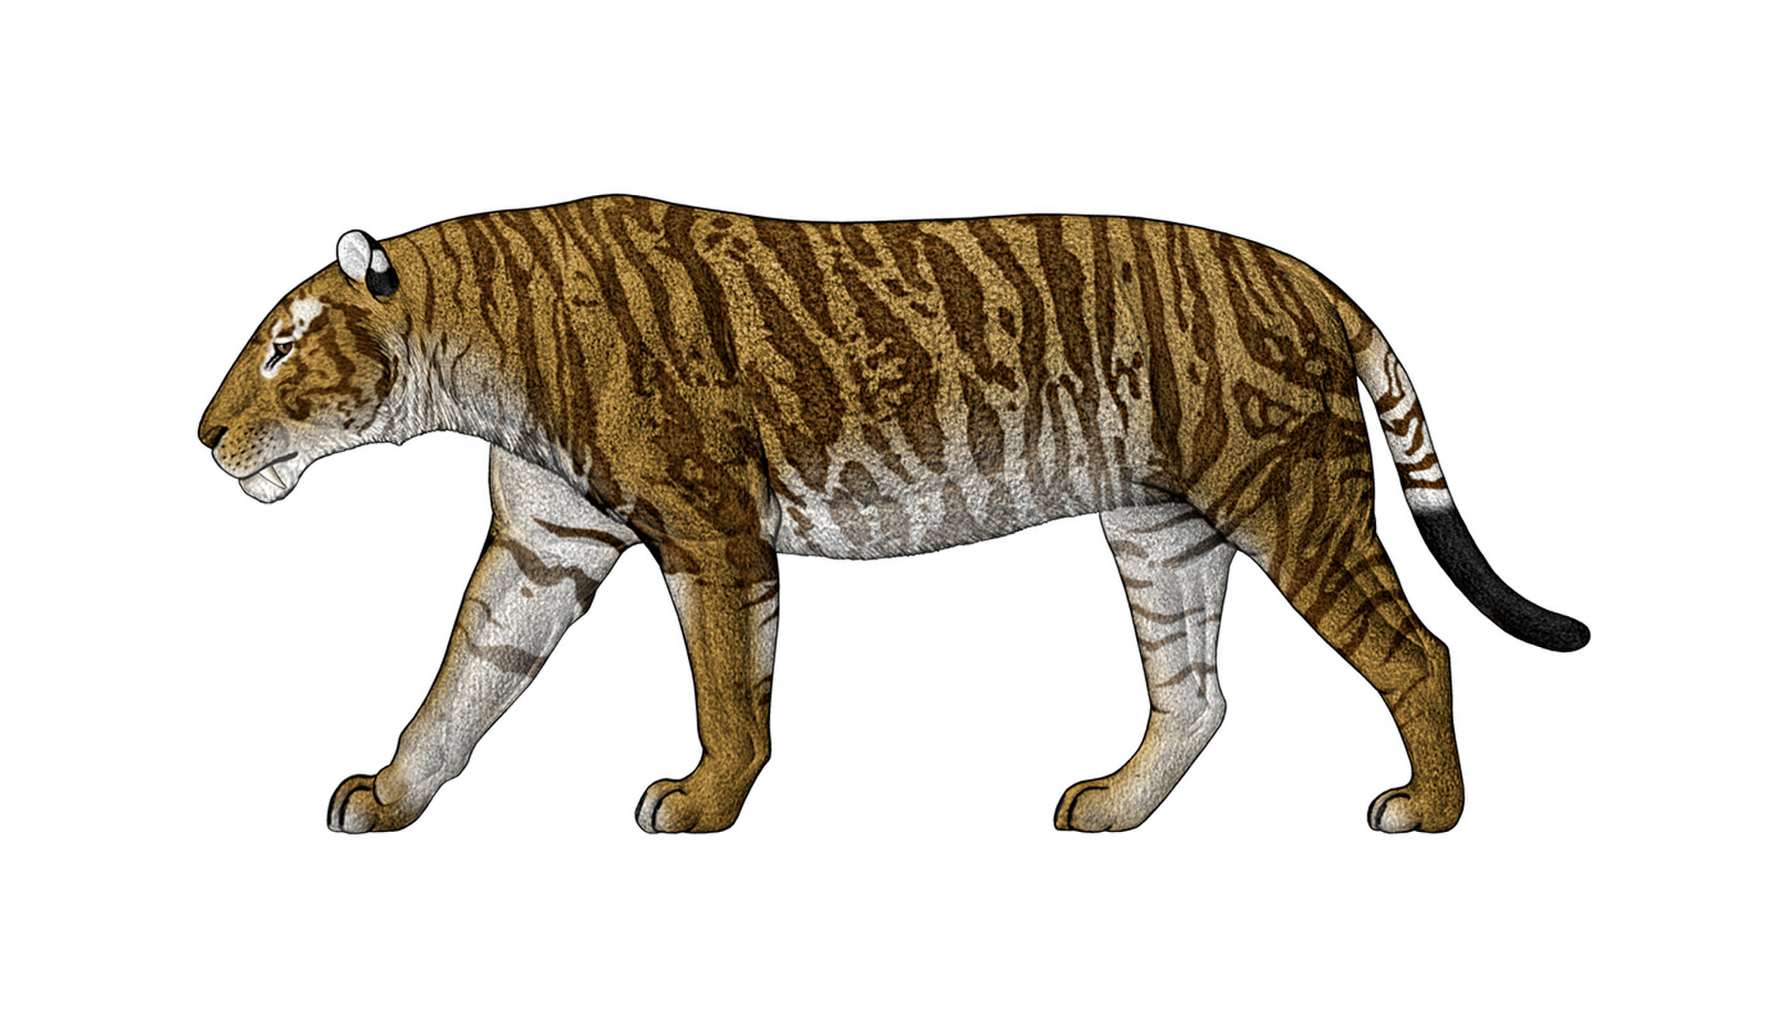
Create four different trading cards including all of the provided information in the template.
The four cards should be
- One Endangered Species
- One Threatened Species
- One Extinct Species (1600s or sooner)
Sample
- One Recovered Species (remove from threated or endangered species list)

Species Common Name
Genus species
Status:
Distribution:

Cause of declines:

Recovery Plan:

Reference

Created by:

Insert Picture Here

Species Common Name
Genus species
Status:
Distribution:

Cause of declines:

Recovery Plan:

Reference

Created by:

Insert Picture Here

Species Common Name
Genus species
Status:
Distribution:

Cause of declines:

Recovery Plan:

Reference

Created by:

Insert Picture Here
Species Common Name
Genus species
Status:
Distribution:

Cause of declines:

Recovery Plan:

Reference

Created by:

Insert Picture Here

