Change image and add caption  Discovery  When was it discovered?  Who discovered it?  How was it discovered? | Where did its name come from?  Melting point:  Boiling point:  At room temperature it is:  Number of protons  Number of neutrons  Number of electrons | Element Name  Atomic number:  Atomic mass:
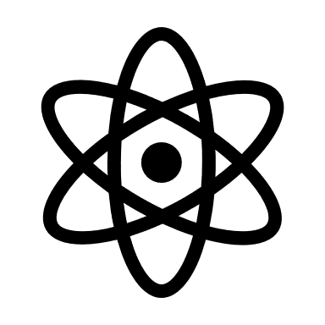  Change image and add caption  More about the properties  One way you could cause a chemical change  One way you could cause a physical change | Two current uses for this element  Two possible ways to use it in the future | Change image and add caption  Created by:  For : GS103 Introduction to Physical Science  Date:  References:

