Uploading Speeches to Blackboard

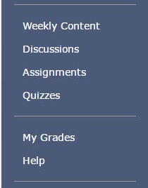

Step One: Finding Where to Upload
Look for the “Assignments” tab on the left-hand side of the course. Click on that and it will lead you to a list of assignments ranging from Week One to Week Eight. Look for the week you want to upload to. Once you click on that week it will lead you to a page that looks like below.

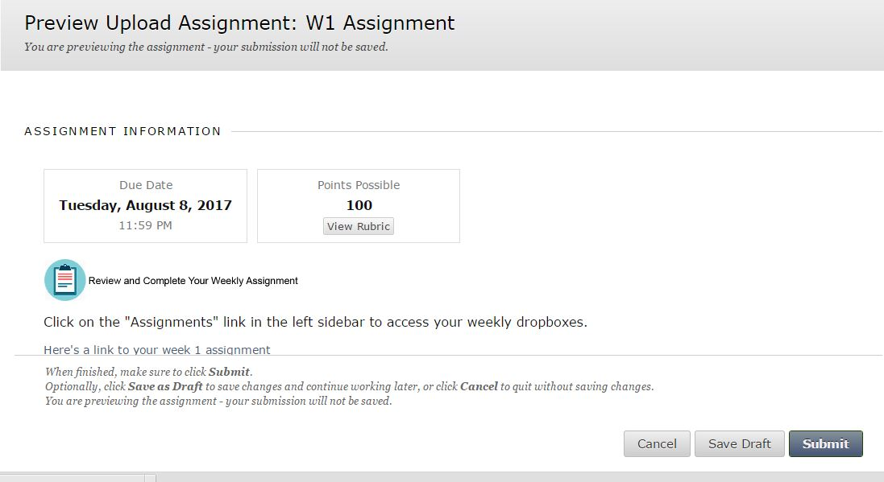

Step Two: Uploading
After you see this page scroll downward. This is where you’ll see options to upload. You will need to click on “Browse My Computer” next to ‘Attach Files’. Picture of this is located below.

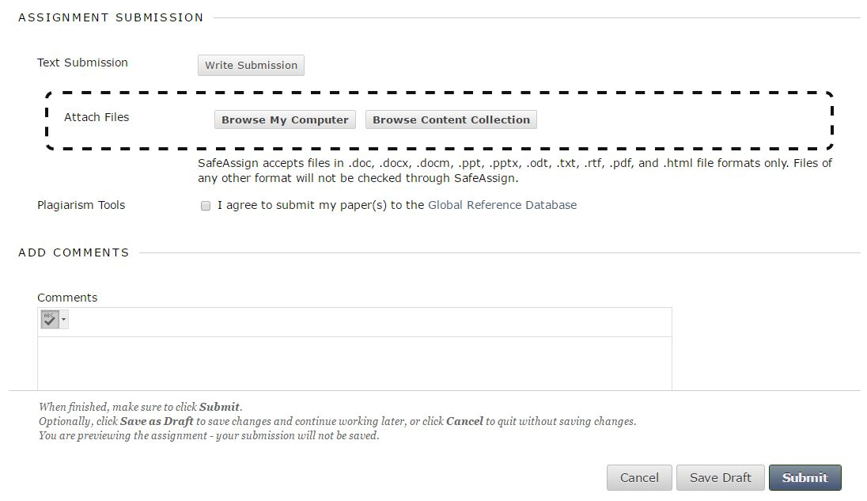
Now you’ll go through your computer files and find your speech video. This is why naming your speech video before submitting will come in handy! Also knowing where your files are uploading to is important. If you have trouble finding your video file look at your program and start a new video to see where it’s saving. Or try calling our tech support at 1-800-955-2527 ext 600 and they can help as well.

Step Three: Be Patient
Uploading takes time! This will take a while to upload. For some it can take up to an hour to upload. That is because this is a much larger file than a paper. You won’t be able to click “Submit” until the file is completely uploaded.
Tips: Leave the page up and stretch your legs or go to a new page (don’t close out this page) to work on something else while it uploads.

Other Options:
Uploading to Blackboard can take a while. Trust me I’m right there with you! It takes me just as long to download your speeches to grade/evaluate them. Other options for uploading are using Google Dropbox, Google Drive, or YouTube. Those may allow you to upload a little quicker. Take a look at the Supplemental Material in the Weekly Content area (at the top) for details on how to upload to those sites. Then use the link they give you to copy and paste it in the comments area for the assignment submission. You’ll need to use the Keyboard shortcut for paste (CTRL) + (V) to paste the link in Blackboard.

