How to Upload to Google Dropbox

Google Dropbox is like a storage system where you can store your videos. It is all private and only those you share your video link with will see be able to see your videos. This is a step by step guide on how to upload your videos to Dropbox and how to share them. For your assignments you can use Dropbox and then copy the video link and paste it in the comment section when submitting.

Step One: First you will need to set up an account. It should be free to use. Once you have it all set up it should look like the photo below.

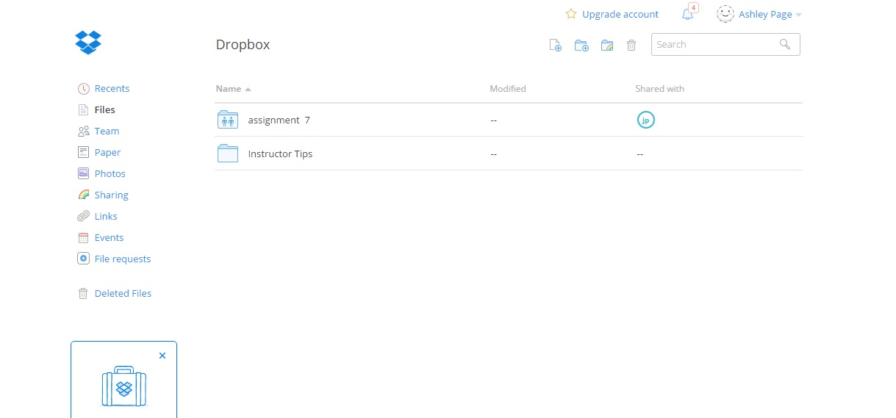

Step Two: Then once you have recorded your videos and know where you saved them on your computer you can upload your video to Dropbox.
To upload look for the paper icon to the left of the search bar. It is circled in red in the photo below.
HINT: Always save your videos in the same folder on your computer. That will help erase any confusion as to where you videos are.
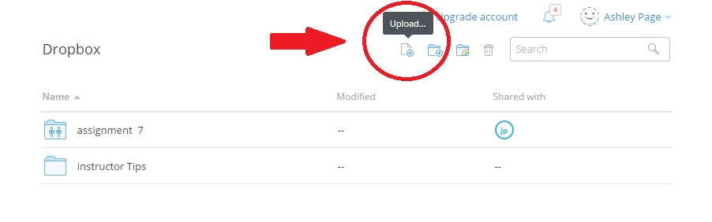
Step Three: Once you have pushed upload it will take you to another screen. This is where you can click “Choose Files”. It will direct you to your computer files. There you can search for your video file. Once you find the video click open at the bottom of the pop up screen.
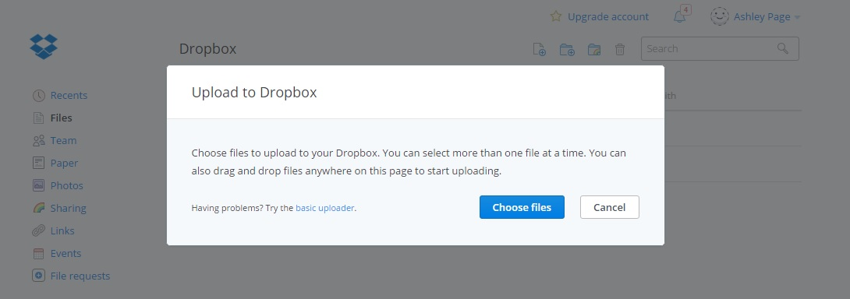

Step Four: It will then start uploading. With this step be patient. It may take a while to upload. Then you push done when it’s finished uploading. Then you are led back to the original screen. Here look for your video. I labeled mine Wildlife in the photos. 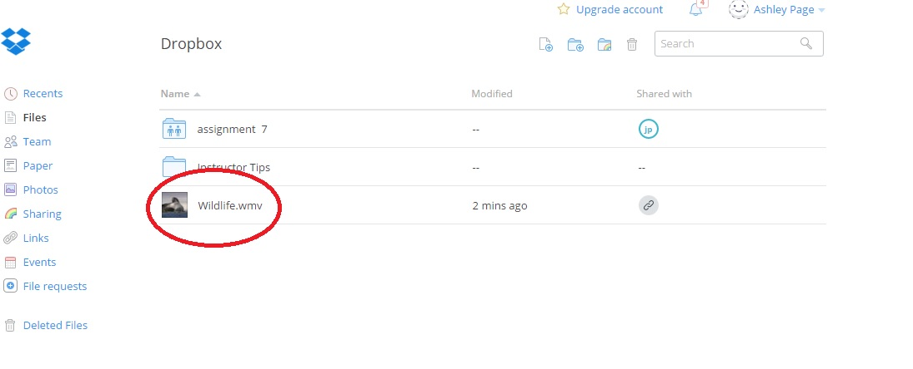
Step Five: From here you hold your cursor (mouse) over the line where you video is. A little button labeled “Share” will pop up.
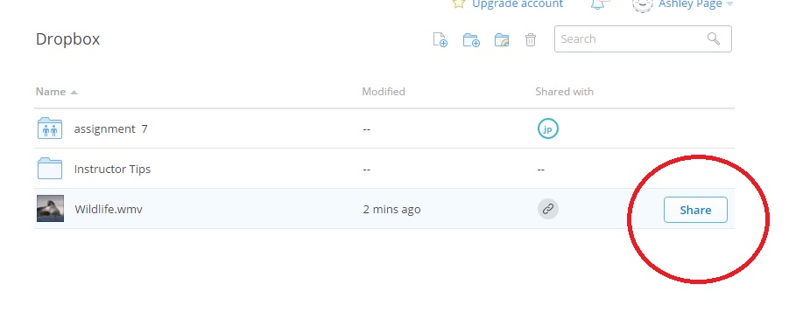
Step Six: Next you will click on share and a new screen will pop up with a link. For the course you will need to copy this link and paste it into the comments section when submitting your speech assignment for the week. I will show both photos.
What’s important to catch in the photo below is the “Send this link to” option. This has been tricky and doesn’t work well. Instead just copy the link.

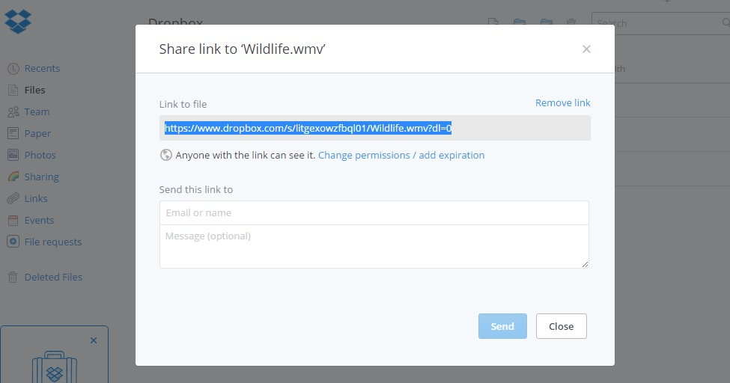

Here is the place where you’ll be copying (CTRL C) and pasting (CTRL V) into the assignment submission area.
