Instruction to use Grantham Library for research

Log into your Blackboard account from Glife.
Approach 1:
In the first approach you can directly use the search option EBSCO from Blackboard’s homepage.
- On the Home page of Blackboard, you will find the Resources tab on the left hand side (On the left hand side you will find “Tools” and under that you will see “Organization Search” and under that you will see “Resources”.
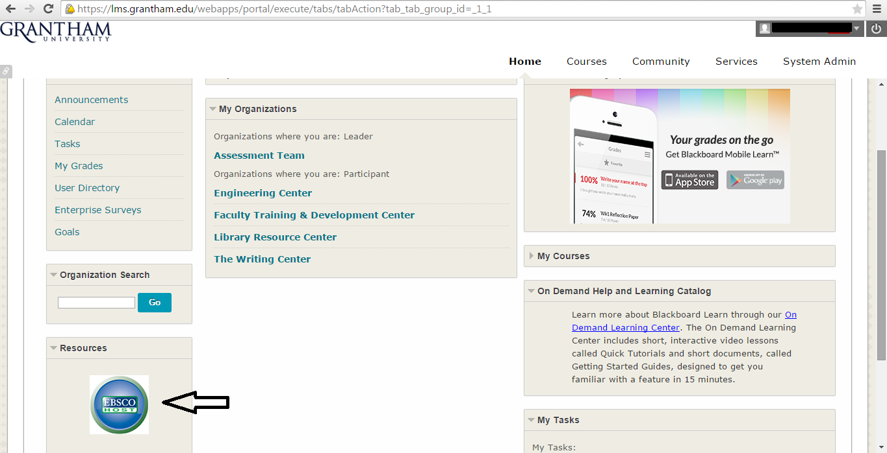

- Use EBSCO link that opens a new window. Then you can choose from “Academic Search Complete” or “Business Source Complete”.
- In the next window, you can type in your search and click “Search”.
- Hundreds of research articles will pop up and you can click on the “PDF Full Text” to view the article.
Approach 2:
In the second approach you can use the “My Organizations” tool from “Community” tab on the Blackboard’s homepage.
- In My Organizations, you will find the Library Resource Center.
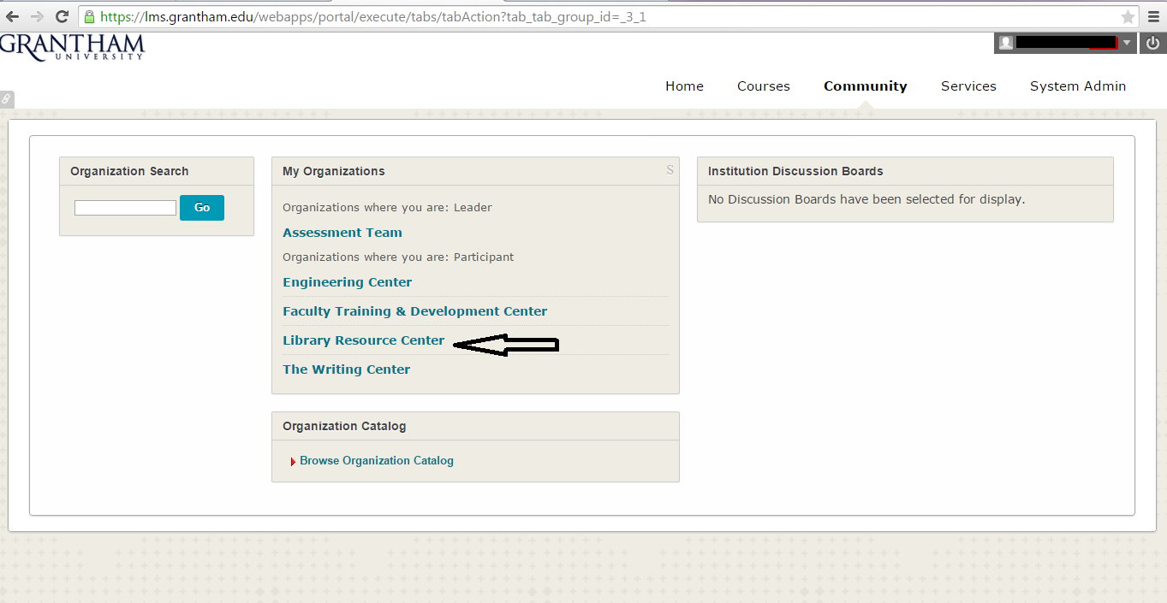

- When you go into the Library Resource Center, on your left hand side you will find the navigation tool. You can choose from Grantham Library Website Resources, Grantham Library Program Specific Websites and EBSCO. There is tutorial for EBSCO for you as well.

- Grantham Library Website Resources: If you choose Grantham Library Website Resources, it will take you to the Library Resources page to look up any website from General Reference, Accessing Libraries, E-books to Government Information.
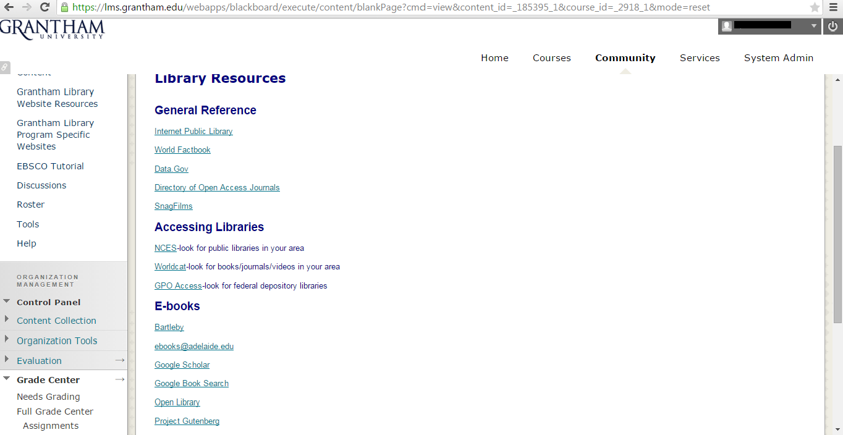

- You can use Google Book Search from E-books and search any book in the database and read it.
- You can also use Open Library from E-books and search any book within the system to read.
- It is your choice to use the any search engine to look up for books or articles to read.

- Grantham Library Program Specific Websites: If you choose Grantham Library Program Specific Websites, it will take you to the Library Resources - Program Specific page to look up any program from Business, Computer Science, Engineering and Science to Health Science and Nursing.
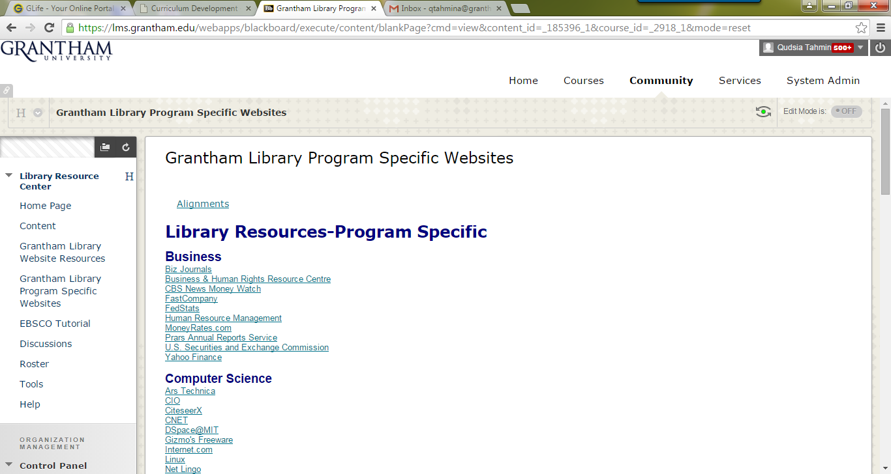

- Scroll down to find Engineering and Science.
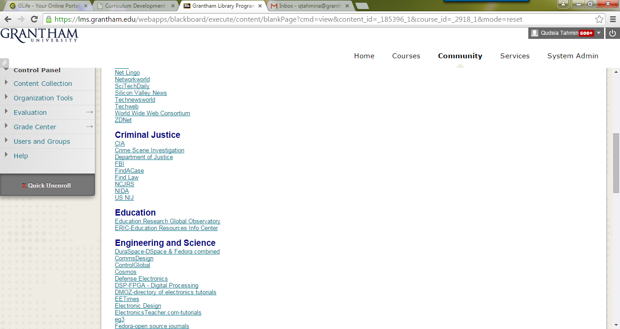

- EBSCO: If you choose EBSCO, it will take you to the “Choose Database” page to look up any database from Academic Search, Business Search to Regional Business News and CINAHL Plus.

