Download Microsoft Project 2013 Tutorial

Step 1 Visit https://www.dreamspark.com/Institution/Access.aspx# and type in Grantham University to find the Grantham DreamSpark WebStore.
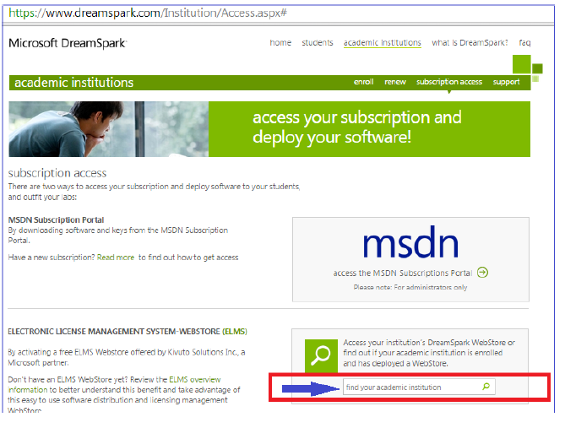

Step 2 – Verify you are on the Grantham Webstore > Grantham University Information Technology DreamSpark Premium

Step 3 Click “Sign In”
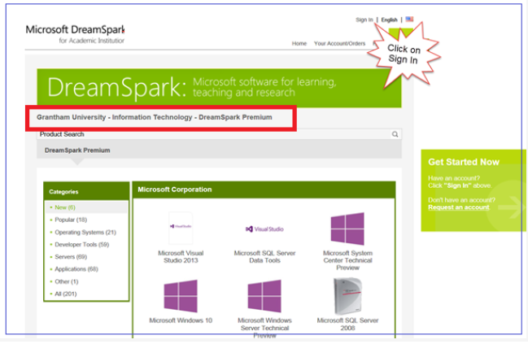

Step 4 Sign In or Register.
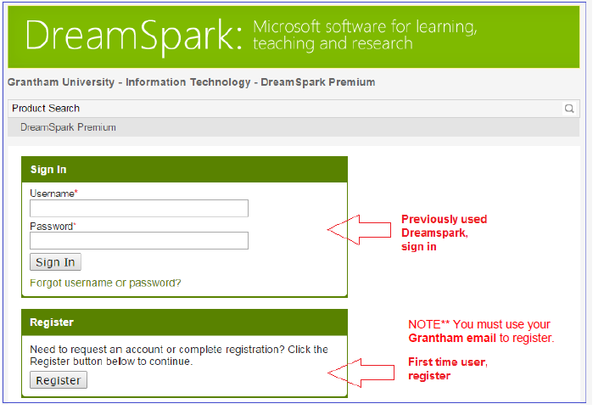
Step 5 If you are registering for the first time, retrieve your sign information via email, then sign in.

NOTE** You must use your Grantham email to register and it may take up to 24 hours to receive your email.

Step 6 – Once you receive Click on Applications from the categories menu on the left side.

Step 7 – Click on the “Microsoft Project 2013” box.
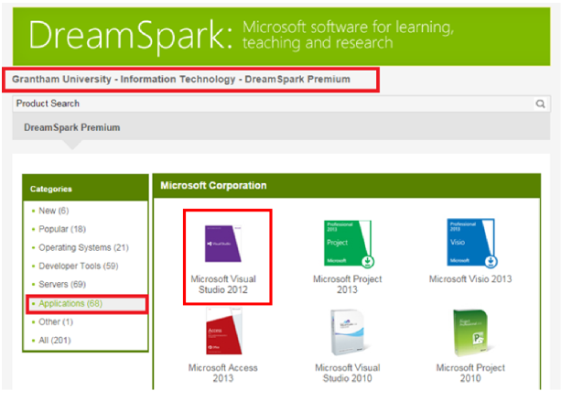

Step 8 – Choose “Add to Cart”
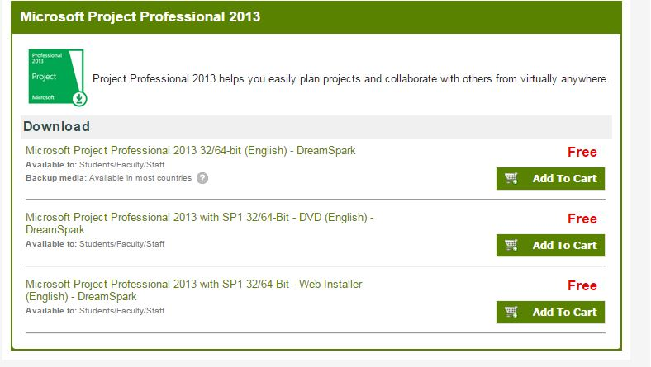
Step 9 – Choose “Check Out”

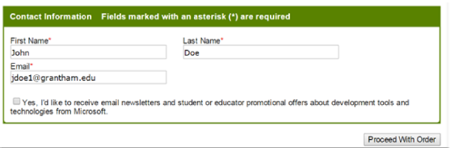

Step 11 – Choose “Proceed with order”.

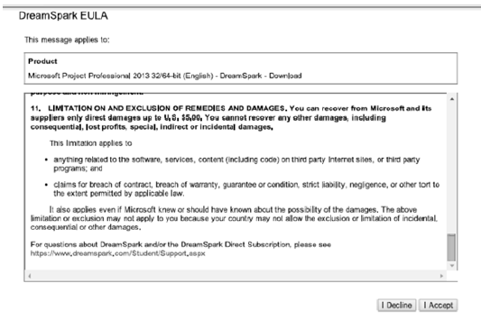
Step 10 – Choose “I Accept” to agree to the terms.

Step 12 – Copy down your Product Key, then Choose “Start Download’.
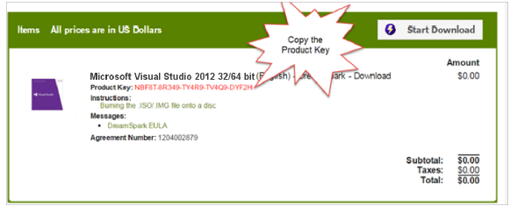
Note** Should you forget to copy your Product Key, you can come back a visit your order history to retrieve.

