Downloading Instructions for Microsoft Office 365 from GLife

Grantham University students can either download a licensed version of Microsoft Office for Educators or use an online version of Microsoft Word, Excel, PowerPoint, Outlook, OneNote, or OneDrive. The download version applies to Windows versions as well as MacIntosh versions. You may also find apps for Android, iPhone/iPad, and Windows tablets and smartphones too.
- Log-in to your Glife website.
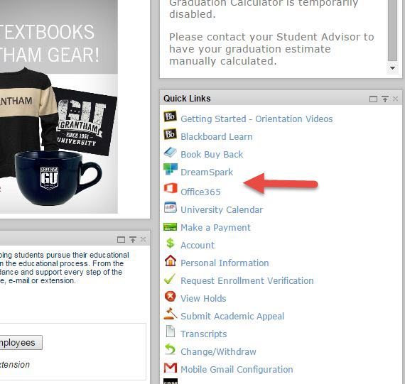

- In the lower right column of the GLife Home page, you will find the link for Office 365. Click on the link to go to the Office 365 website.

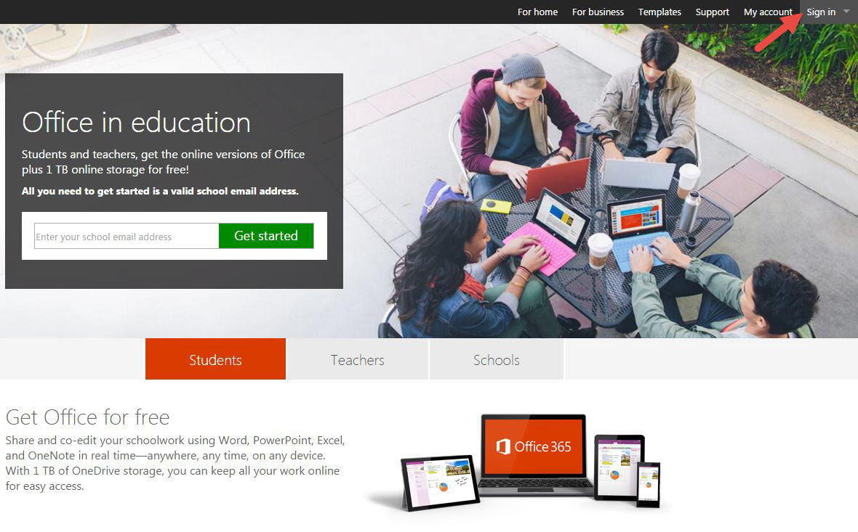
- If you are logging in for the first time, you will need to enter your Grantham email address and click on the green Get Started button. If you have been to this site before, you can login with your account at Sign In option in the Upper right corner (Red arrow). You will advance to Step 6.
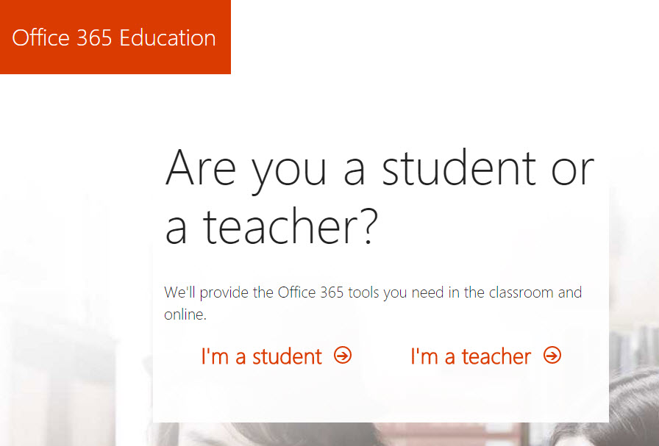

- The first step in creating an account is indicating whether you are a student or a teacher. Click on the ‘I’m a student’ option.
- The website will deliver an email to your Grantham account to verify that it is a legitimate student account. Within your email, you will receive the following message. You will need to click on the ‘Yes, that’s me’ red button to verify and continue.
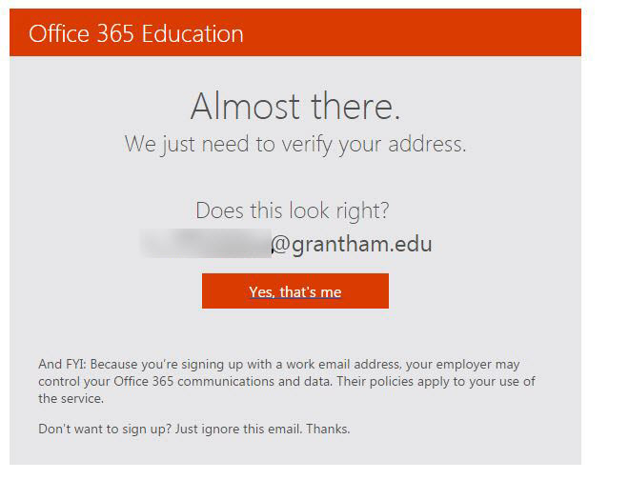

- The last step in registration is to fill out your basic information to create an account. You will be asked to fill out your first and last name, desired password and birth date for verification. After you complete the form, click on the Start button. This indicates that you acknowledge and agree to the terms and conditions of the account.
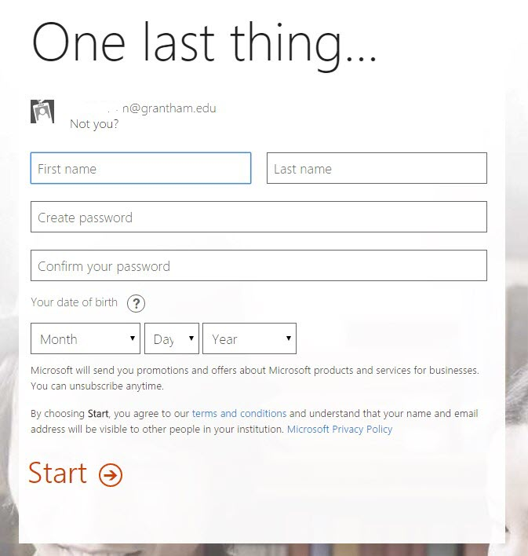

- Ultimately, you can an account to open all of your Microsoft accounts.
- At the prompt window for sign up, enter your Grantham email and password. You can have the browser save your Sign-in information to bypass this step.
- Once you are logged in, the Office 365 Education menu will appear. At the top of the window, you have a choice to download the PC version of Word, Excel, PowerPoint, Outlook, and OneNote by clicking the Install now button. If you have a Mac, the website should display the Mac version instead.
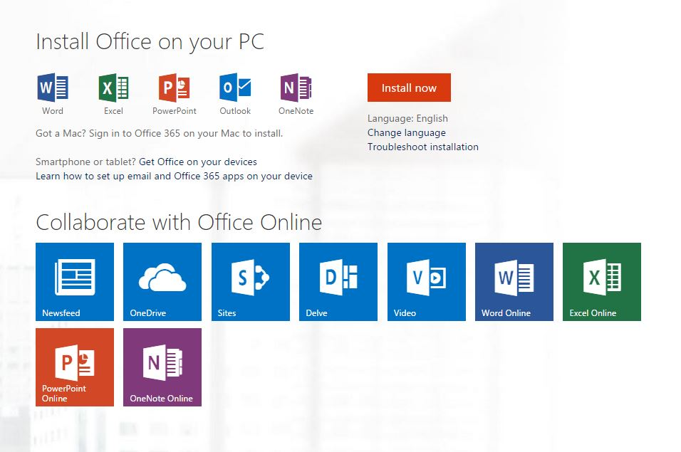
- If you would prefer to use the Office Online feature instead, where you can use the Office application online instead of your desktop, you can launch the application with the respective buttons for each program available. There are several options in handling your files creating on Office online. Microsoft provides a few types to manage documents or videos as well. It is best to experiment with these choices to determine if one or more is best for you.
- Just below the PC version, there is a line and link “Get Office for your Devices.” This link will give you the Device menu to download the correct app for your smartphone or tablet.



